**LAPORAN RESMI**

**PRAKTIKUM PEMROGAMAN WEB**

**MINGGU 13**



**Oleh:**

**Ahmed Indarafata Akmal M.S.**

**1 D4 Teknik Informatika A**

**3120600017**

**Listing**

**PERCOBAAN**

upload.php

<?php

// folder penenmapatan untuk file yang diupload bisa disesuaikan

// selama php bisa membaca folder tersebut

$uploadDir = 'file/';

if (isset($_POST['upload'])) {

     $fileName = $_FILES['userfile']['name'];

     $tmpName = $_FILES['userfile']['tmp_name'];

     $fileSize = $_FILES['userfile']['size'];

     $fileType = $_FILES['userfile']['type'];

     $filePath = $uploadDir . $fileName;

     $result = move_uploaded_file($tmpName, $filePath);

        if (!$result) {

            echo "Error uploading file";

            exit;

        }

        include 'koneksi_db.php';

        if (!get_magic_quotes_gpc()) {

            $fileName = addslashes($fileName);

            $filePath = addslashes($filePath);

        }

$query = "INSERT INTO upload(name, size, type, path ) VALUES('$fileName', '$fileSize', '$fileType', '$filePath')";

mysqli_query($conn,$query) or die('Error, query failed : ' . mysqli_error());

        include 'close_db.php';

        echo "<br>File uploaded<br>";

}

?>

<!DOCTYPE html>

<head>

    <body>

        <form action="upload.php" method="post" enctype="multipart/form-data">

            Select image to upload:

            <input type="file" name="userfile" id="fileToUpload">

            <input type="submit" value="Upload" name="upload">

        </form>

    </body>

</head>

Analisa:

Code diatas digunakan untuk mengupload suatu file sehingga nantinya file dapat diunduh oleh user.

download.php

<?php

if (isset($_GET['id'])) {

    include 'koneksi_db.php';

    $id = $_GET['id'];

    $query = "SELECT name, type, size, content FROM upload WHERE id =" .$id;

    $result = mysqli_query($conn, $query) or die('Error, query failed');

    list($name, $type, $size, $content) = mysqli_fetch_array($result);

    header("Content-Disposition: attachment; filename=$name");

    header("Content-length: $size");

    header("Content-type: $type");

    echo $content;

    include 'close_db.php';

    exit;

}

?>

<html>

    <head>

        <title>Download File From MySQL</title>

        <meta http-equiv="Content-Type" content="text/html; charset=iso-8859-1">

    </head>

    <body>

        <?php

        include 'koneksi_db.php';

        $query = "SELECT id, name, path, size, type FROM upload";

        $result = mysqli_query($conn, $query) or die('Error, query failed');

        if (mysqli_num_rows($result) == 0) {

            echo "Database is empty <br>";

        } else {

            while (list($id, $name, $path, $size, $type) = mysqli_fetch_array($result)) {

              ?>

              <a href="<?php echo $path;?>"><?php echo $name;?><?php echo $type;?><?php echo $size;?></a><br>

              <?php

            }

         }

        include 'close_db.php';

        ?>

    </body>

</html>

Analisa:

Code diatas digunakan untuk mengunduh file yang sebelumnya sudah diupload oleh user.

**PRAKTIKUM**

prak_upload.php

<?php

session_start();

if(!$_SESSION['user_is_logged_in']){

    header("Location: login_siswa.php");

    exit;

}

?>

<!DOCTYPE html>

<html  lang="en">

<head>

    <style>

        #navbarNav{

        font-size:21px

        }

        #navmenu{

        font-size:21px

        }

        #navmenu{

            color:rgb(190, 190, 190);

            text-decoration: none;

        }

        #navmenu:hover{

            color:rgb(231, 231, 231);

        }

        *{

            box-sizing: border-box;

            -webkit-box-sizing: border-box;

            -moz-box-sizing: border-box;

        }

        body{

            font-family: Helvetica;

            -webkit-font-smoothing: antialiased;

            background: linear-gradient(to left, #3E6294 , #a9abdc);

        }

        .section-content{

        text-align: center;

        }

        .section-header{

            font-family: 'Teko', sans-serif;

            color : #fff;

        }

        h2{

            text-align: center;

            font-size: 18px;

            text-transform: uppercase;

            letter-spacing: 1px;

            color: white;

            padding: 30px 0;

        }

        /* Table Styles */

        .table-wrapper{

            margin: 10px 70px 70px;

        }

        .fl-table {

            border-radius: 5px;

            font-size: 12px;

            font-weight: normal;

            border: none;

            border-collapse: collapse;

            width: 100%;

            max-width: 100%;

            white-space: nowrap;

            background-color: white;

        }

        .fl-table td, .fl-table th {

            text-align: center;

            padding: 8px;

        }

        .fl-table td {

            border-right: 1px solid #f8f8f8;

            font-size: 12px;

        }

        .fl-table thead th {

            color: #ffffff;

            background: #4FC3A1;

        }

        .fl-table thead th:nth-child(odd) {

            color: #ffffff;

            background: #324960;

        }

        .fl-table tr:nth-child(even) {

            background: #F8F8F8;

        }

        /* Responsive */

        @media (max-width: 767px) {

            .fl-table {

                display: block;

                width: 100%;

            }

            .table-wrapper:before{

                content: "Scroll horizontally >";

                display: block;

                text-align: right;

                font-size: 11px;

                color: white;

                padding: 0 0 10px;

            }

            .fl-table thead, .fl-table tbody, .fl-table thead th {

                display: block;

            }

            .fl-table thead th:last-child{

                border-bottom: none;

            }

            .fl-table thead {

                float: left;

            }

            .fl-table tbody {

                width: auto;

                position: relative;

                overflow-x: auto;

            }

            .fl-table td, .fl-table th {

                padding: 20px .625em .625em .625em;

                height: 60px;

                vertical-align: middle;

                box-sizing: border-box;

                overflow-x: hidden;

                overflow-y: auto;

                width: 120px;

                font-size: 13px;

                text-overflow: ellipsis;

            }

            .fl-table thead th {

                text-align: left;

                border-bottom: 1px solid #f7f7f9;

            }

            .fl-table tbody tr {

                display: table-cell;

            }

            .fl-table tbody tr:nth-child(odd) {

                background: none;

            }

            .fl-table tr:nth-child(even) {

                background: transparent;

            }

            .fl-table tr td:nth-child(odd) {

                background: #F8F8F8;

                border-right: 1px solid #E6E4E4;

            }

            .fl-table tr td:nth-child(even) {

                border-right: 1px solid #E6E4E4;

            }

            .fl-table tbody td {

                display: block;

                text-align: center;

            }

            .tambah{

                margin: 10px 70px 70px;

            }

        }

#form_upload{

  position: absolute;

  top: 50%;

  left: 50%;

  margin-top: -100px;

  margin-left: -250px;

  width: 500px;

  height: 200px;

  border: 4px dashed #fff;

}

#form_upload p{

  width: 100%;

  height: 100%;

  text-align: center;

  line-height: 170px;

  color: #ffffff;

  font-family: Arial;

}

#form_upload input{

  position: absolute;

  margin: 0;

  padding: 0;

  width: 100%;

  height: 100%;

  outline: none;

  opacity: 0;

}

#form_upload button{

  margin: 0;

  color: #fff;

  background: #16a085;

  border: none;

  width: 508px;

  height: 35px;

  margin-top: -20px;

  margin-left: -4px;

  border-radius: 4px;

  border-bottom: 4px solid #117A60;

  transition: all .2s ease;

  outline: none;

}

#form_upload button:hover{

  background: #149174;

    color: #0C5645;

}

#form_upload button:active{

  border:0;

}

    </style>

    <meta charset="UTF-8">

    <meta name="viewport" content="width=device-width, initial-scale=1.0">

    <link rel="stylesheet" href="https://maxcdn.bootstrapcdn.com/bootstrap/4.5.2/css/bootstrap.min.css">

        <script src="https://ajax.googleapis.com/ajax/libs/jquery/3.5.1/jquery.min.js"></script>

        <script src="https://cdnjs.cloudflare.com/ajax/libs/popper.js/1.16.0/umd/popper.min.js"></script>

        <script src="https://maxcdn.bootstrapcdn.com/bootstrap/4.5.2/js/bootstrap.min.js"></script>

    <title>Sebelum Login</title>

    <link rel="stylesheet" href="bootstrap.min.css">

    <link rel="stylesheet" href="main.css">

</head>

<body>

    <nav class="navbar navbar-expand-lg navbar-dark bg-dark">

        <div class="container-fluid">

            <div class="navbar-menu d-flex align-items-center justify-content-between w-100">

                <div class="left-menu d-flex align-items">

                    <button class="navbar-toggler" type="button" data-toggle="collapse" data-target="#navbarNav"

                        aria-controls="navbarNav" aria-expanded="false" aria-label="Toggle navigation">

                        <span class="navbar-toggler-icon"></span>

                    </button>

                    <div class="collapse navbar-collapse" id="navbarNav">

                        <ul class="navbar-nav">

                            <li class="nav-item dropdown">

                                <a class="nav-link dropdown-toggle" href="javascript:void(0)"

                                    id="navbarDropdownMenuLink" data-toggle="dropdown" aria-haspopup="true"

                                    aria-expanded="false">

                                    Menu

                                </a>

                                <div class="dropdown-menu bg-dark" aria-labelledby="navbarDropdownMenuLink" id="navmenu">

                                    <a class="dropdown-item bg bg-dark" href="prak_upload.php" style="color:white">Upload File</a>

                                    <a class="dropdown-item bg bg-dark" href="prak_download.php" style="color:white">Download File</a>

                                </div>

                            </li>

                        </ul>

                    </div>

                </div>

                <div class="right-menu d-flex flex-row-reverse align-items-center">

                    <a class="btn"  href="logout_siswa.php" id="navmenu">Logout</a>

                    <a class="btn"  href="logout_siswa.php" id="navmenu">Profile</a>

                    <form class="form-inline my-2 my-lg-0">

                        <input class="form-control mr-sm-2" type="search" placeholder="Cari" aria-label="Cari">

                        <a href="search sebelum login.html" class="btn btn-outline-success my-2 my-sm-0" type="submit">Cari</a>

                    </form>

                </div>

            </div>

        </div>

    </nav>

</div>

<div class="container">

    <form id="form_upload" action="insert_upload.php" method="post" enctype="multipart/form-data">

        <input type="file" name="userfile" id="fileToUpload">

        <p>Drag your files here or click in this area.</p>

        <button type="submit"><input type="submit" value="Upload" name="upload">Upload</button>

    </form>

</div>

</body>

<script src="asset/js/jquery-3.5.1.min.js"></script>

<script src="asset/js/bootstrap.min.js"></script>

<script src="asset/js/popper.min.js"></script>

</html>

Analisa:

Code diatas digunakan untuk mennyediakan form untuk mengupload sebuah file.

insert_upload.php

<?php

// folder penenmapatan untuk file yang diupload bisa disesuaikan

// selama php bisa membaca folder tersebut

$uploadDir = 'file/';

if (isset($_POST['upload'])) {

     $fileName = $_FILES['userfile']['name'];

     $tmpName = $_FILES['userfile']['tmp_name'];

     $fileSize = $_FILES['userfile']['size'];

     $fileType = $_FILES['userfile']['type'];

     $filePath = $uploadDir . $fileName;

     $result = move_uploaded_file($tmpName, $filePath);

        if (!$result) {

            echo "Error uploading file";

            exit;

        }

        include 'koneksi_db.php';

        if (!get_magic_quotes_gpc()) {

            $fileName = addslashes($fileName);

            $filePath = addslashes($filePath);

        }

$query = "INSERT INTO upload(name, size, type, path ) VALUES('$fileName', '$fileSize', '$fileType', '$filePath')";

mysqli_query($conn,$query) or die('Error, query failed : ' . mysqli_error());

        include 'close_db.php';

        echo "<br>File uploaded<br>";

}

header('Location: prak_download.php');

?>

Analisa:

Setelah user meng klik upload pada code sebelumnya, maka file yang telah diberikan oleh user tadi akan diupload ke dalam server.

prak_download.php

<?php

session_start();

if(!$_SESSION['user_is_logged_in']){

    header("Location: login_siswa.php");

    exit;

}

?>

<!DOCTYPE html>

<html  lang="en">

<head>

    <style>

        #navbarNav{

        font-size:21px

        }

        #navmenu{

        font-size:21px

        }

        #navmenu{

            color:rgb(190, 190, 190);

            text-decoration: none;

        }

        #navmenu:hover{

            color:rgb(231, 231, 231);

        }

        *{

            box-sizing: border-box;

            -webkit-box-sizing: border-box;

            -moz-box-sizing: border-box;

        }

        body{

            font-family: Helvetica;

            -webkit-font-smoothing: antialiased;

            background: linear-gradient(to left, #3E6294 , #a9abdc);

        }

        .section-content{

        text-align: center;

        }

        .section-header{

            font-family: 'Teko', sans-serif;

            color : #fff;

        }

        h2{

            text-align: center;

            font-size: 18px;

            text-transform: uppercase;

            letter-spacing: 1px;

            color: white;

            padding: 30px 0;

        }

        /* Table Styles */

        .table-wrapper{

            margin: 10px 70px 70px;

        }

        .fl-table {

            border-radius: 5px;

            font-size: 12px;

            font-weight: normal;

            border: none;

            border-collapse: collapse;

            width: 100%;

            max-width: 100%;

            white-space: nowrap;

            background-color: white;

        }

        .fl-table td, .fl-table th {

            text-align: center;

            padding: 8px;

        }

        .fl-table td {

            border-right: 1px solid #f8f8f8;

            font-size: 12px;

        }

        .fl-table thead th {

            color: #ffffff;

            background: #4FC3A1;

        }

        .fl-table thead th:nth-child(odd) {

            color: #ffffff;

            background: #324960;

        }

        .fl-table tr:nth-child(even) {

            background: #F8F8F8;

        }

        /* Responsive */

        @media (max-width: 767px) {

            .fl-table {

                display: block;

                width: 100%;

            }

            .table-wrapper:before{

                content: "Scroll horizontally >";

                display: block;

                text-align: right;

                font-size: 11px;

                color: white;

                padding: 0 0 10px;

            }

            .fl-table thead, .fl-table tbody, .fl-table thead th {

                display: block;

            }

            .fl-table thead th:last-child{

                border-bottom: none;

            }

            .fl-table thead {

                float: left;

            }

            .fl-table tbody {

                width: auto;

                position: relative;

                overflow-x: auto;

            }

            .fl-table td, .fl-table th {

                padding: 20px .625em .625em .625em;

                height: 60px;

                vertical-align: middle;

                box-sizing: border-box;

                overflow-x: hidden;

                overflow-y: auto;

                width: 120px;

                font-size: 13px;

                text-overflow: ellipsis;

            }

            .fl-table thead th {

                text-align: left;

                border-bottom: 1px solid #f7f7f9;

            }

            .fl-table tbody tr {

                display: table-cell;

            }

            .fl-table tbody tr:nth-child(odd) {

                background: none;

            }

            .fl-table tr:nth-child(even) {

                background: transparent;

            }

            .fl-table tr td:nth-child(odd) {

                background: #F8F8F8;

                border-right: 1px solid #E6E4E4;

            }

            .fl-table tr td:nth-child(even) {

                border-right: 1px solid #E6E4E4;

            }

            .fl-table tbody td {

                display: block;

                text-align: center;

            }

            .tambah{

                margin: 10px 70px 70px;

            }

        }

    </style>

    <meta charset="UTF-8">

    <meta name="viewport" content="width=device-width, initial-scale=1.0">

    <link rel="stylesheet" href="https://maxcdn.bootstrapcdn.com/bootstrap/4.5.2/css/bootstrap.min.css">

        <script src="https://ajax.googleapis.com/ajax/libs/jquery/3.5.1/jquery.min.js"></script>

        <script src="https://cdnjs.cloudflare.com/ajax/libs/popper.js/1.16.0/umd/popper.min.js"></script>

        <script src="https://maxcdn.bootstrapcdn.com/bootstrap/4.5.2/js/bootstrap.min.js"></script>

    <title>Sebelum Login</title>

    <link rel="stylesheet" href="bootstrap.min.css">

    <link rel="stylesheet" href="main.css">

</head>

<body>

    <nav class="navbar navbar-expand-lg navbar-dark bg-dark">

        <div class="container-fluid">

            <div class="navbar-menu d-flex align-items-center justify-content-between w-100">

                <div class="left-menu d-flex align-items">

                    <button class="navbar-toggler" type="button" data-toggle="collapse" data-target="#navbarNav"

                        aria-controls="navbarNav" aria-expanded="false" aria-label="Toggle navigation">

                        <span class="navbar-toggler-icon"></span>

                    </button>

                    <div class="collapse navbar-collapse" id="navbarNav">

                        <ul class="navbar-nav">

                            <li class="nav-item dropdown">

                                <a class="nav-link dropdown-toggle" href="javascript:void(0)"

                                    id="navbarDropdownMenuLink" data-toggle="dropdown" aria-haspopup="true"

                                    aria-expanded="false">

                                    Menu

                                </a>

                                <div class="dropdown-menu bg-dark" aria-labelledby="navbarDropdownMenuLink" id="navmenu">

                                    <a class="dropdown-item bg bg-dark" href="prak_upload.php" style="color:white">Upload File</a>

                                    <a class="dropdown-item bg bg-dark" href="prak_download.php" style="color:white">Download File</a>

                                </div>

                            </li>

                        </ul>

                    </div>

                </div>

                <div class="right-menu d-flex flex-row-reverse align-items-center">

                    <a class="btn"  href="logout_siswa.php" id="navmenu">Logout</a>

                    <a class="btn"  href="logout_siswa.php" id="navmenu">Profile</a>

                    <form class="form-inline my-2 my-lg-0">

                        <input class="form-control mr-sm-2" type="search" placeholder="Cari" aria-label="Cari">

                        <a href="search sebelum login.html" class="btn btn-outline-success my-2 my-sm-0" type="submit">Cari</a>

                    </form>

                </div>

            </div>

        </div>

    </nav>

</div>

<?php

if (isset($_GET['id'])) {

    include 'koneksi_db.php';

    $id = $_GET['id'];

    $query = "SELECT name, type, size, content FROM upload WHERE id =" .$id;

    $result = mysqli_query($conn, $query) or die('Error, query failed');

    list($name, $type, $size, $content) = mysqli_fetch_array($result);

    header("Content-Disposition: attachment; filename=$name");

    header("Content-length: $size");

    header("Content-type: $type");

    echo $content;

    include 'close_db.php';

    exit;

}

?>

        <div class="table-wrapper">

        <table border="1" class="fl-table">

            <tr id="firstrow">

                <th>ID</th>

                <th>Nama File</th>

                <th>Tipe</th>

                <th>Ukuran</th>

            </tr>

            <?php

                include 'koneksi_db.php';

                $query = "SELECT id, name, path, size, type FROM upload";

                $result = mysqli_query($conn, $query) or die('Error, query failed');

                if (mysqli_num_rows($result) == 0) {

                    echo "Database is empty <br>";

                } else {

                    while (list($id, $name, $path, $size, $type) = mysqli_fetch_array($result)) {

                        ?>

                        <tr>

                            <td> <a href="<?php echo $path;?>"><?php echo $id;?></a> </a>

                            <td> <a href="<?php echo $path;?>"><?php echo $name;?></a> </td>

                            <td> <a href="<?php echo $path;?>"><?php echo $type;?></a> </td>

                            <td> <a href="<?php echo $path;?>"><?php echo $size;?></a> </td>

                        </tr>

                        <?php

                    }

                }

        include 'close_db.php';

        ?>

        </table>

</body>

<script src="asset/js/jquery-3.5.1.min.js"></script>

<script src="asset/js/bootstrap.min.js"></script>

<script src="asset/js/popper.min.js"></script>

</html>

Analisa:

Code diatas digunakan untuk mengunduh file yang sebelumnya sudah diupload oleh user kedalam server.

daftar_siswa.php

<!DOCTYPE html>

<html>

    <head>

        <meta http-equiv="Content-Type" content="text/html; charset=iso-8859-1">

        <style>

            body {

            background: black;

            background-repeat: no-repeat;

            width: 100%;

            min-height: 768px;

        }

        #card {

            background: #fbfbfb;

            border-radius: 8px;

            box-shadow: 1px 2px 8px rgba(0, 0, 0, 0.65);

            height: 400px;

            margin: 6rem auto 8.1rem auto;

            width: 490px;

        }

        #card-content {

            padding: 12px 44px;

        }

        #card-title {

            font-family: "Raleway Thin", sans-serif;

            letter-spacing: 4px;

            padding-bottom: 23px;

            padding-top: 13px;

            text-align: center;

        }

        .underline-title {

            background: -webkit-linear-gradient(right, #307ace, #19048d);

            height: 2px;

            margin: -1.1rem auto 0 auto;

            width: 89px;

        }

        a {

            text-decoration: none;

        }

        label {

            font-family: "Raleway", sans-serif;

            font-size: 11pt;

        }

        #forgot-pass {

            color: black;

            font-family: "Raleway", sans-serif;

            font-size: 10pt;

            margin-top: 3px;

            text-align: right;

        }

        .form {

            align-items: left;

            display: flex;

            flex-direction: column;

        }

        .form-border {

            background: black;

            height: 1px;

            width: 100%;

        }

        .form-content {

            background: #fbfbfb;

            border: none;

            outline: none;

            padding-top: 14px;

        }

        #signup {

            color: #0085FF;

            font-family: "Raleway", sans-serif;

            font-size: 10pt;

            margin-top: 16px;

            text-align: center;

        }

        #submit-btn {

            background: -webkit-linear-gradient(right, #307ace, #19048d);

            border: none;

            border-radius: 21px;

            box-shadow: 0px 1px 5px #0085FF;

            cursor: pointer;

            color: white;

            font-family: "Raleway SemiBold", sans-serif;

            height: 42.3px;

            margin: 0 auto;

            margin-top: 50px;

            transition: 0.25s;

            width: 153px;

        }

        #submit-btn:hover {

            box-shadow: 0px 5px 20px rgba(0, 0, 0, 0.3);

        }

        </style>

    </head>

    <body>

        <?php

        if ($errorMessage != '') {

            ?>

            <p align="center"><strong><font color="#990000"><?php echo $errorMessage; ?></font></strong></p>

            <?php

        }

        ?>

            <div id="card">

        <div id="card-content">

            <div id="card-title">

                <h2>Daftar</h2>

                <div class="underline-title"></div>

            </div>

        </div>

        <form action="insert_siswa.php" method="post" name="frmLogin" id="frmLogin" class="form">

            <label for="user-password" style="padding-top:22px">&nbsp;Username</label>

            <input id="user-password" class="form-content" type="text" name="Username">

            <div class="form-border"></div><label for="user-password" style="padding-top:22px">&nbsp;Password</label>

            <input id="user-password" class="form-content" type="password" name="Password">

            <div class="form-border"></div>

            <a style="text-align: center;"><button id="submit-btn" type="submit">Berikutnya</button></a>

        </form>

    </div>

    </body>

</html>

Analisa:

Untuk dapat mengakses halaman upload maupun download, user diharuskan melakukan login dahulu. Jika user belum memiliki akun maka user dapat melakukan pendaftaran dengan code diatas dimana data yang perlu diisikan adalah username dan password.

insert_siswa.php

<?php

include 'koneksi_db.php';

$Username = $_POST['Username'];

$Pswd = $_POST['Password'];

$sql = "INSERT INTO akun(Username, Pswd) VALUES('$Username', '$Pswd')";

if(mysqli_query($conn, $sql))

    echo "Data berhasil ditambahkan";

else

    echo "Data gagal masuk";

mysqli_close($conn);

header("location: login_siswa.php");

?>

Analisa:

Setelah user mendaftar, maka data yang telah diberikan oleh user tadi diinsertkan kedalam database dengan menggunakan method POST seperti yang dapat dilihat pada code diatas

login_siswa.php

<?php

session_start();

$errorMessage = '';

if (isset($_POST['username']) && isset($_POST['password'])) {

    include 'koneksi_db.php';

    $Username = $_POST['username'];

    $Password = $_POST['password'];

    $sql = "SELECT * FROM akun WHERE Username = '$Username' AND Pswd ='$Password'";

    $result = mysqli_query($conn, $sql);

    if (mysqli_num_rows($result) == 1) {

        $row = mysqli_fetch_assoc($result);

        $_SESSION['user_is_logged_in'] = true;

        header('Location: prak_upload.php');

        exit;

    } else {

        $errorMessage = 'Sorry, wrong user id / password';

    }

    include 'closedb.php';

}

?>

<html>

    <head>

        <title>Basic Login</title>

        <meta http-equiv="Content-Type" content="text/html; charset=iso-8859-1">

        <style>

            body {

            background: black;

            background-repeat: no-repeat;

            width: 100%;

            min-height: 768px;

        }

        #card {

            background: #fbfbfb;

            border-radius: 8px;

            box-shadow: 1px 2px 8px rgba(0, 0, 0, 0.65);

            height: 450px;

            margin: 6rem auto 8.1rem auto;

            width: 410px;

        }

        #card-content {

            padding: 12px 44px;

        }

        #card-title {

            font-family: "Raleway Thin", sans-serif;

            letter-spacing: 4px;

            padding-bottom: 23px;

            padding-top: 13px;

            text-align: center;

        }

        .underline-title {

            background: black;

            height: 2px;

            margin: -1.1rem auto 0 auto;

            width: 89px;

        }

        a {

            text-decoration: none;

        }

        label {

            font-family: "Raleway", sans-serif;

            font-size: 11pt;

        }

        #forgot-pass {

            color: black;

            font-family: "Raleway", sans-serif;

            font-size: 10pt;

            margin-top: 3px;

            text-align: right;

        }

        .form {

            align-items: left;

            display: flex;

            flex-direction: column;

        }

        .form-border {

            background: black;

            height: 1px;

            width: 100%;

        }

        .form-content {

            background: #fbfbfb;

            border: none;

            outline: none;

            padding-top: 14px;

        }

        #signup {

            color: #0085FF;

            font-family: "Raleway", sans-serif;

            font-size: 10pt;

            margin-top: 16px;

            text-align: center;

        }

        #submit-btn {

            background: -webkit-linear-gradient(right, #307ace, #19048d);

            border: none;

            border-radius: 21px;

            box-shadow: 0px 1px 5px #0085FF;

            cursor: pointer;

            color: white;

            font-family: "Raleway SemiBold", sans-serif;

            height: 42.3px;

            margin: 0 auto;

            margin-top: 50px;

            transition: 0.25s;

            width: 153px;

        }

        #submit-btn:hover {

            box-shadow: 0px 5px 20px rgba(0, 0, 0, 0.3);

        }

        </style>

    </head>

    <body>

        <?php

        if ($errorMessage != '') {

            ?>

            <p align="center"><strong><font color="#990000"><?php echo $errorMessage; ?></font></strong></p>

            <?php

        }

        ?>

            <div id="card">

        <div id="card-content">

            <div id="card-title">

                <h2>LOGIN</h2>

                <div class="underline-title"></div>

            </div>

        </div>

        <form action="login_siswa.php" method="post" name="frmLogin" id="frmLogin" class="form">

            <label for="user-email" style="padding-top:13px">&nbsp;&nbsp;&nbsp;&nbsp;Username</label>

            <input id="user-email" class="form-content" type="text" name="username" autocomplete="on" />

            <div class="form-border"></div><label for="user-password" style="padding-top:22px">&nbsp;&nbsp;&nbsp;&nbsp;Password</label>

            <input id="user-password" class="form-content" type="password" name="password" />

            <div class="form-border"></div>

            <a style="text-align: center;"><button id="submit-btn" type="submit">Login</button></a>

            <a href="daftar_siswa.php" id="signup">Belum memiliki akun? Daftar</a>

        </form>

    </div>

    </body>

</html>

Analisa:

Setelah user mendaftar user dapat melakukan login agar bisa mengakses web ini. Setelah user memasukkan username dan password maka username dan password tersebut akan dicek kedalam database apakah ada username dan password yang sesuai. Jika ada maka halaman akan diredirect kehalaman prak_download.php, namun jika tidak maka akan muncul pesan eror berwarna merah.

logout_siswa.php

<?php

session_start();

if (isset($_SESSION['user_is_logged_in'])) {

    unset($_SESSION['user_is_logged_in']);

}

header('Location: login_siswa.php');

?>

Analisa:

Code diatas berfungsi untuk user jika ingin melakukan logout dengan cara mengakhiri session, sehingga data yang disimpan dalam session akan dihilangkan dan user harus melakukan login Kembali untuk bisa mengakses website upload/download.

koneksi_db.php

<?php

$servername = "localhost";

$username = "root";

$password = "";

$dbname = "ppw";

$conn = mysqli_connect($servername, $username, $password, $dbname);

if(!$conn)

    die("Koneksi Gagal : " . mysqli_connect_error());

else

    //echo "Koneksi Berhasil<br/>";

?>

Analisa:

Code diatas digunakan untuk menghubungkan website kedalam database yang telah disediakan.

close_db.php

<?php

    mysqli_close($conn);

?>

Analisa:

Code diatas digunakan untuk menutup database.

**Output:**

daftar_siswa.php

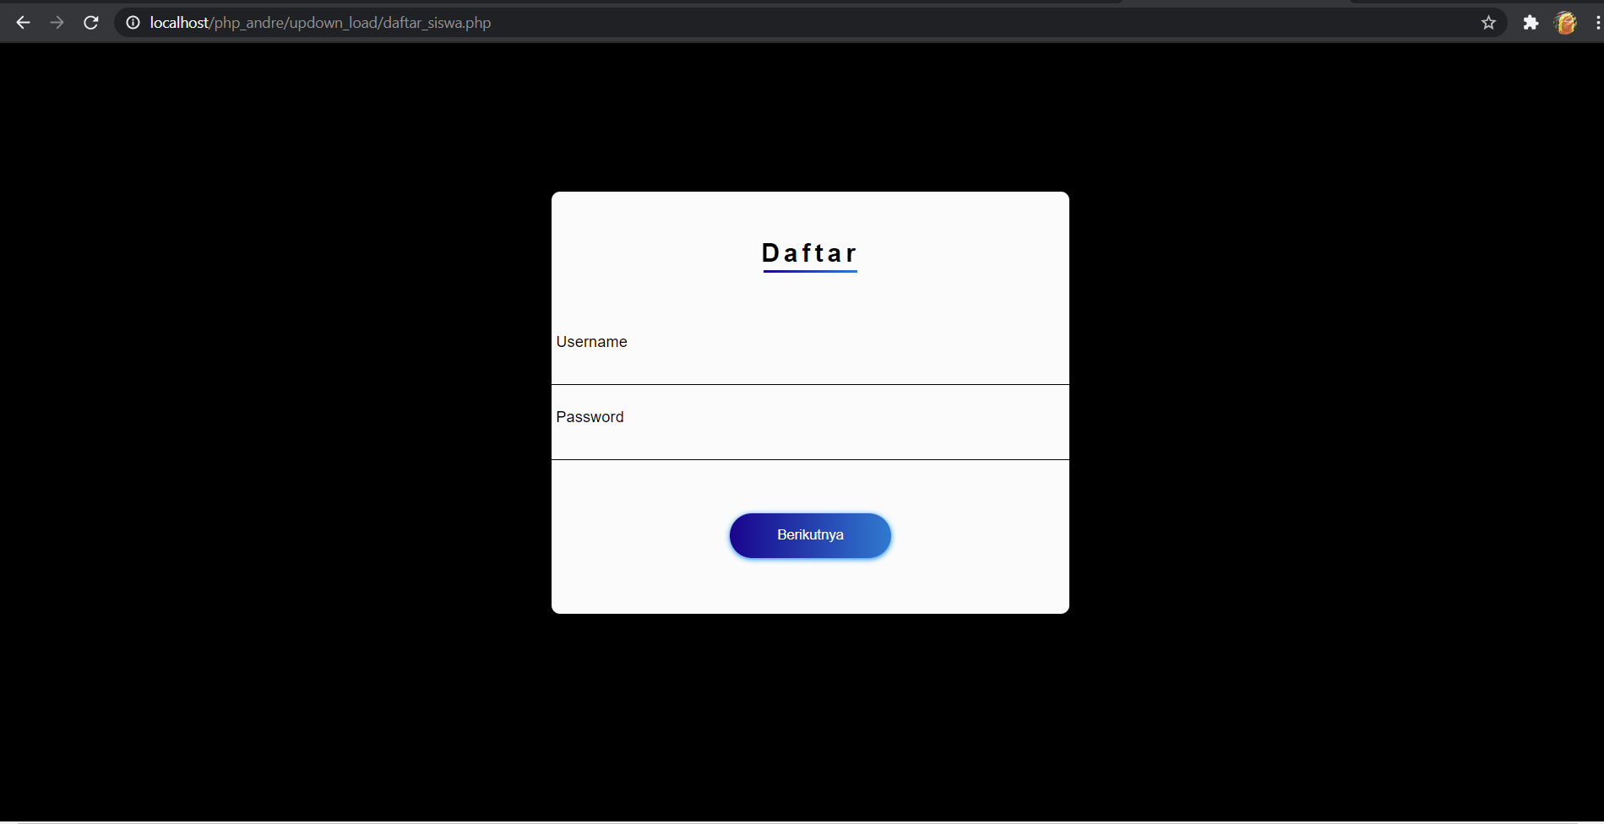

login_siswa.php

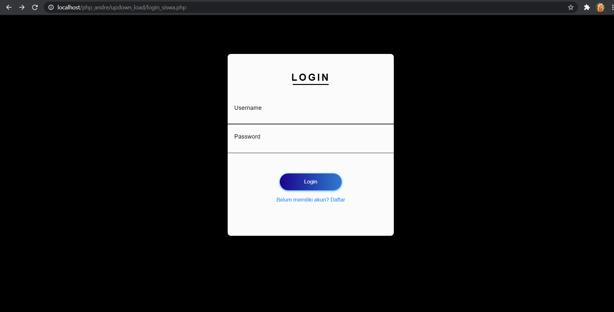

prak_upload.php

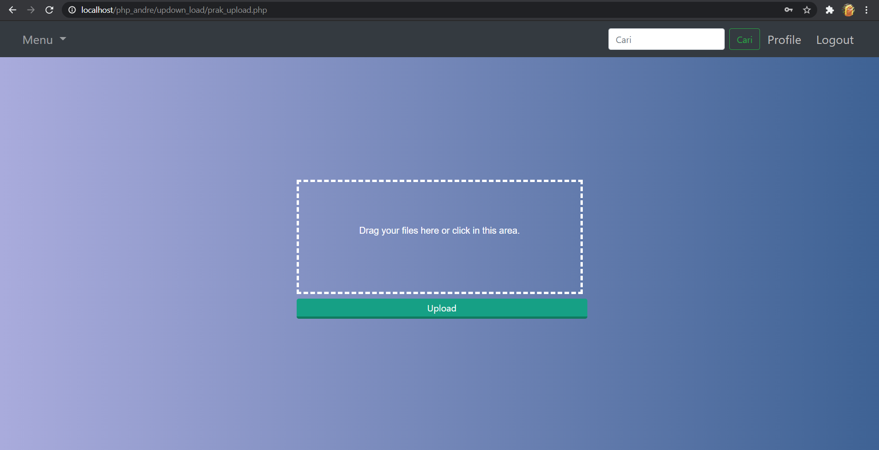

prak_download.php

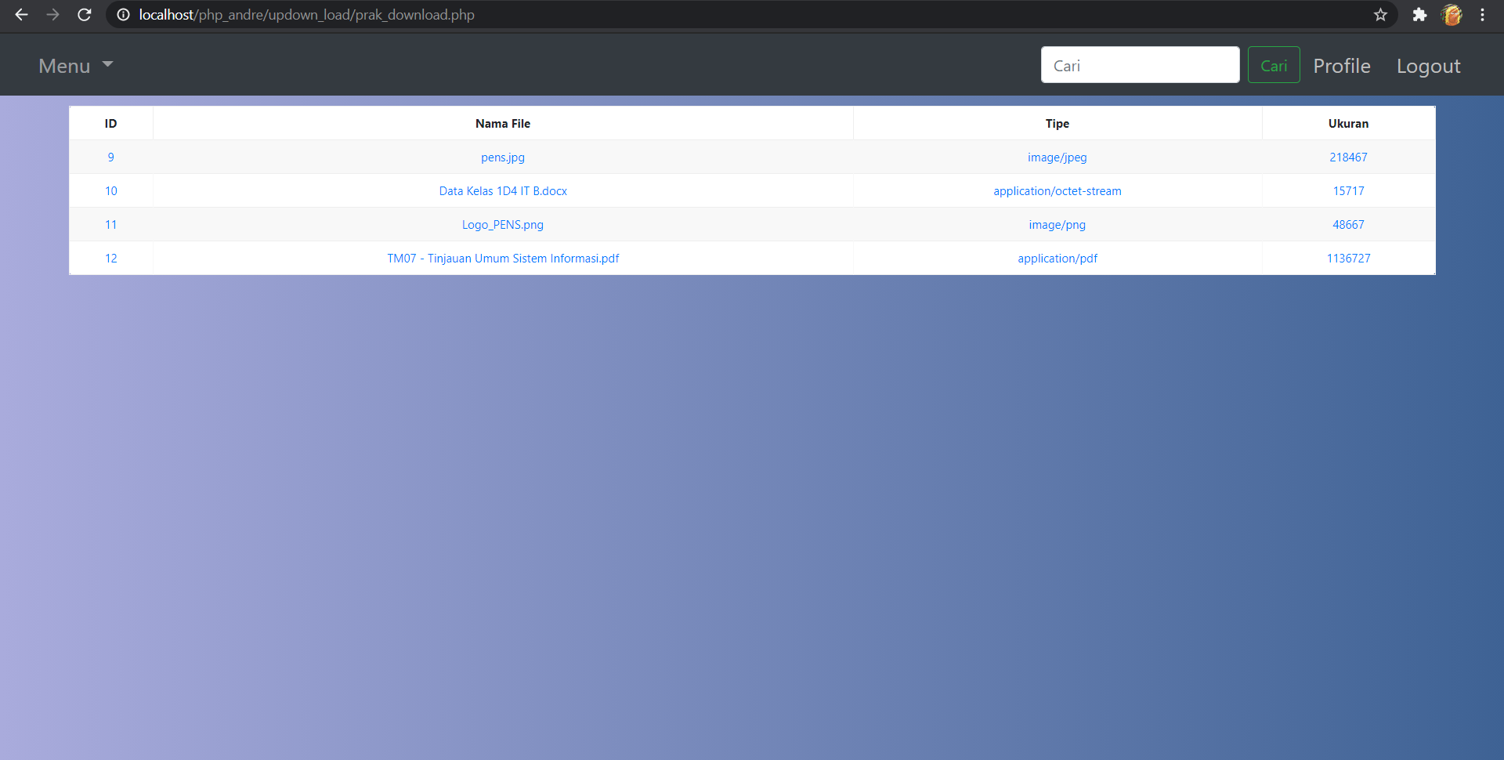

Kesimpulan:

Dari percobaan dan praktikum yang telah saya lakukan diatas dapat saya simpulkan bahwa kita dapat melakukan upload file ke server dengan mudah menggunakan php. Untuk membuat program upload file dengan php yang pertama dilakukan adalah pastikan konfigurasi pada php sudah diijinkan untuk melakukan upload file. Adapun untuk membuat form upload pastikan menggunakan methode POST dan form harus diberi atribut enctype=”multipart/form-data”.